# Task 1

Now your friend has followed a lot of different food bloggers, he needs to analyse the habits of these bloggers.

* 1. From the list of Instagram handles you obtained when you searched ‘food’ in previous project. Open the first 10 handles and find the top 5 which have the highest number of followers
  2. Now find the number of posts these handles have done in the previous 3 days.
  3. Depict this information using a suitable graph.

Sol:

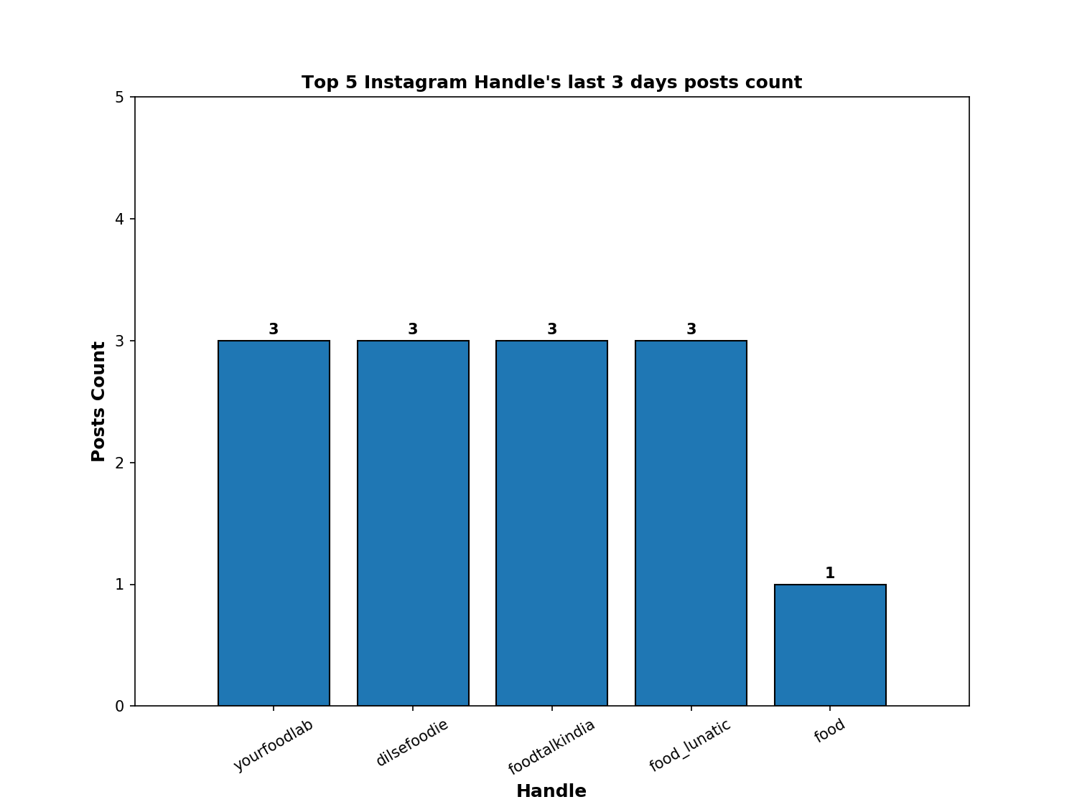

* From the above plot we can say that he handles of yourfoodlab, dilsefoodie, foodtalkindia, food_lunatic and food are the top 5 food handles.
* Also we can see that the number of posted they have posted in last 3 days.

# Task 2

# Your friend also needs a list of hashtags that he should use in his posts.

* 1. Open the 5 handles you obtained in the last question, and scrape the content of the first 10 posts of each handle.
  2. Prepare a list of all words used in all the scraped posts and calculate the frequency of each word.
  3. Create a csv file with two columns : the word and its frequency
  4. Now, find the hashtags that were most popular among these bloggers
  5. Plot a Pie Chart of the top 5 hashtags obtained and the number of times they were used by these bloggers in the scraped posts.

Sol:

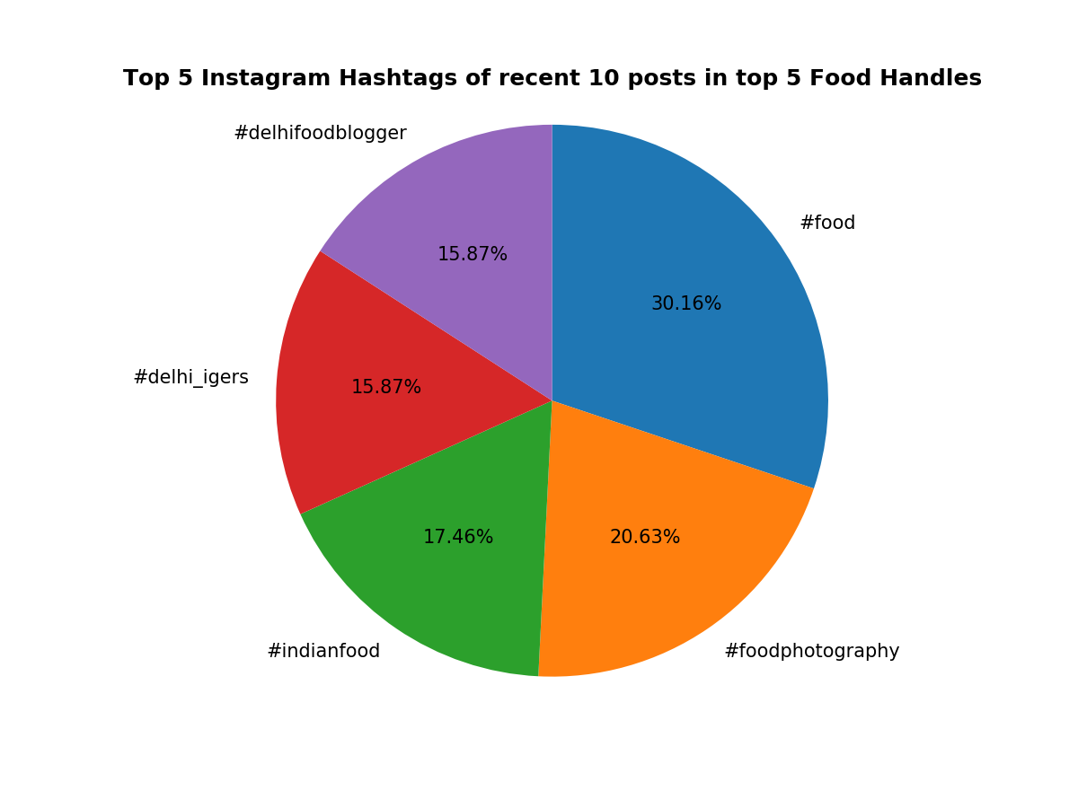

* From the above Pie chart, we can see the that the top five hashtags were using by the top 10 posts of top 5 food handles in Instagram are #food, #foodphotography, #indianfood, #delhi_igers, and #delhifoodblooger.
* Also we can see the frequency of that each hashtag with the percentage in the above plot
* Attached the CSV file which have the words (hashtags) and their frequency.

# Task 3

You need to also calculate average followers: likes ratio for the obtained handles.  
Followers: Likes ratio is calculated as follows:

* 1. Find out the likes of the top 10 posts of the 5 handles obtained earlier.
  2. Calculate the average likes for a handle.

3.3 Divide the average likes obtained from the number of followers of the handle to get the average followers: like ratio of each handle.

* 1. Create a bar graph to depict the above obtained information.

Sol:

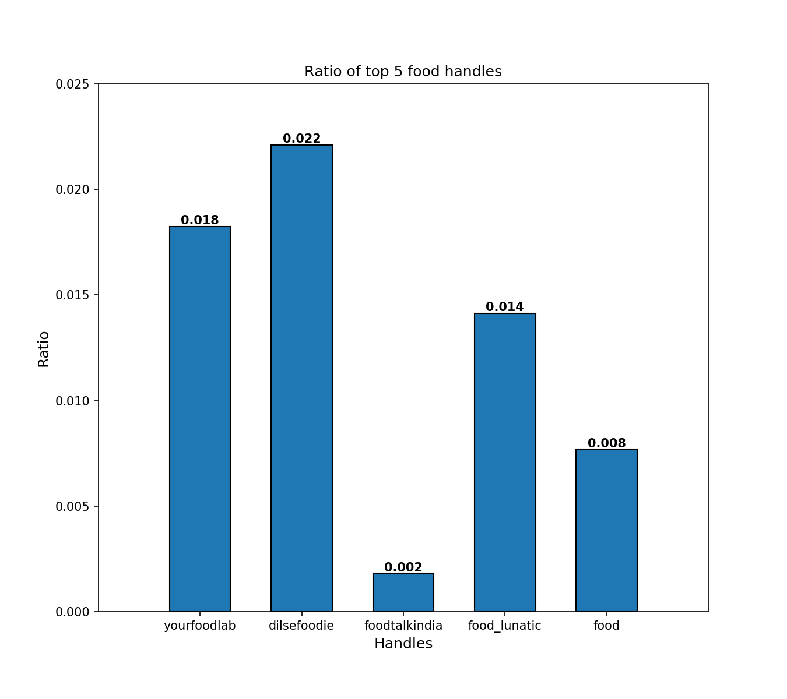

* From the above bar chart, we can see that the handles yourfoodlab, dilsefoodie, foodtalkindia, food_lunatic and food with their ratio (which calculated by considering their top 10 posts likes received and their followers count).
* As we can see dilsefoodie, yourfoodlab and food_lunatic are the top three handles with high ratio.

**Overall Insights :**

* We can see that the top three handles dilsefoodie, yourfoodlab and food_lunatic which having good ratio are also actually in the first plot of (handles which have posted more posts in last three days.)
* We can consider these three Instagram Handles as most active in recent days.